Table of Contents

1 Supervisor Module User Manual

1.1 1. Role Objective
The Supervisor (Admin) role manages operational control from assignment through resolution and closure, including escalations, quality checks, and knowledge publication.

1.2 2. Module List (Supervisor)
- Login
- Dashboard
- Tickets
- Create Ticket
- Escalation
- Knowledge Hub
- Call Logs
- Audit Logs
- Clients
- Products
- Device/Equipment Categories
- Types of Service
- Reports
- Settings

1.3 3. Login Module
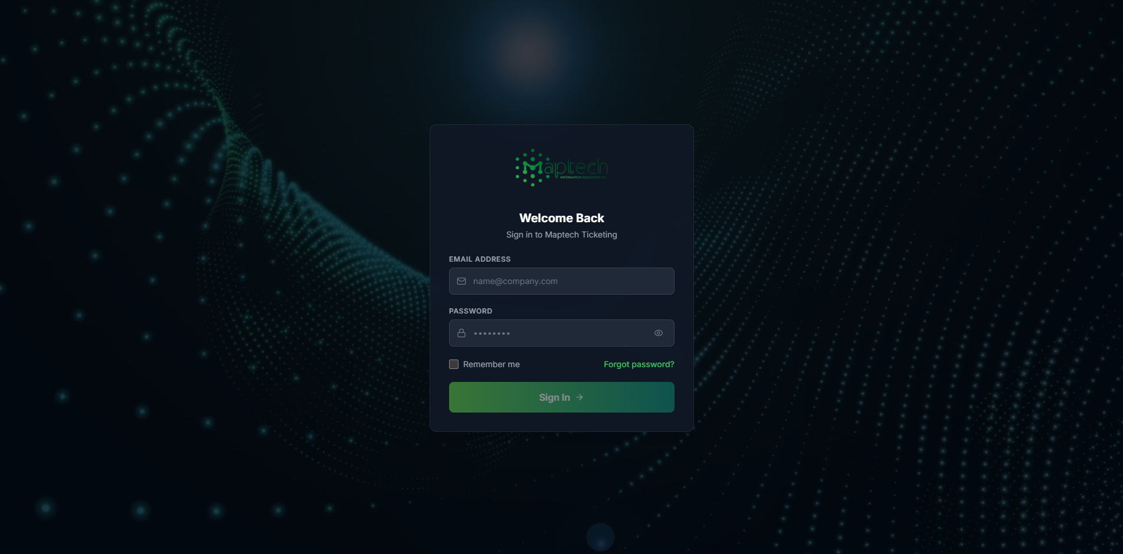
Supervisor Login
Steps: 1. Enter supervisor credentials. 2. Click Sign In. 3. Confirm redirect to Supervisor dashboard.

1.4 4. Dashboard Module
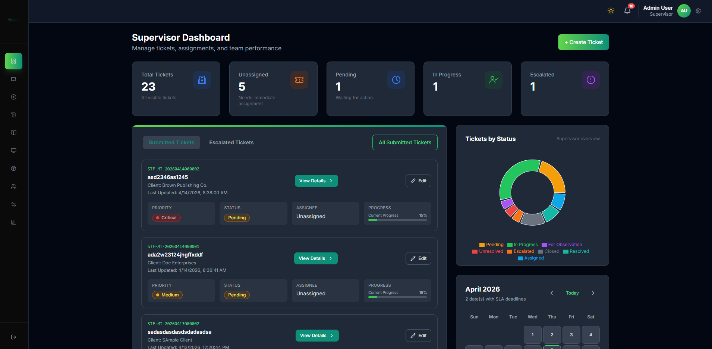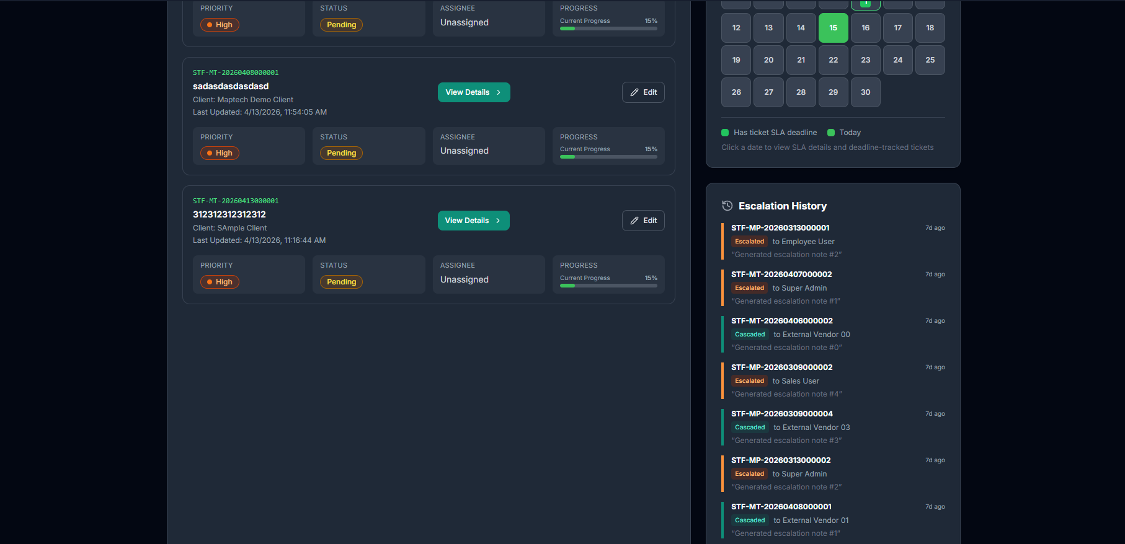
Purpose: - Monitor overall ticket workload and status distribution. - Track submitted tickets, escalations, and calendar/SLA cues.
Daily Supervisor Checklist: 1. Review unassigned and high-priority tickets. 2. Check pending closure queue. 3. Check escalated tickets requiring action. 4. Review calendar/SLA urgency items.

1.5 5. Tickets Module
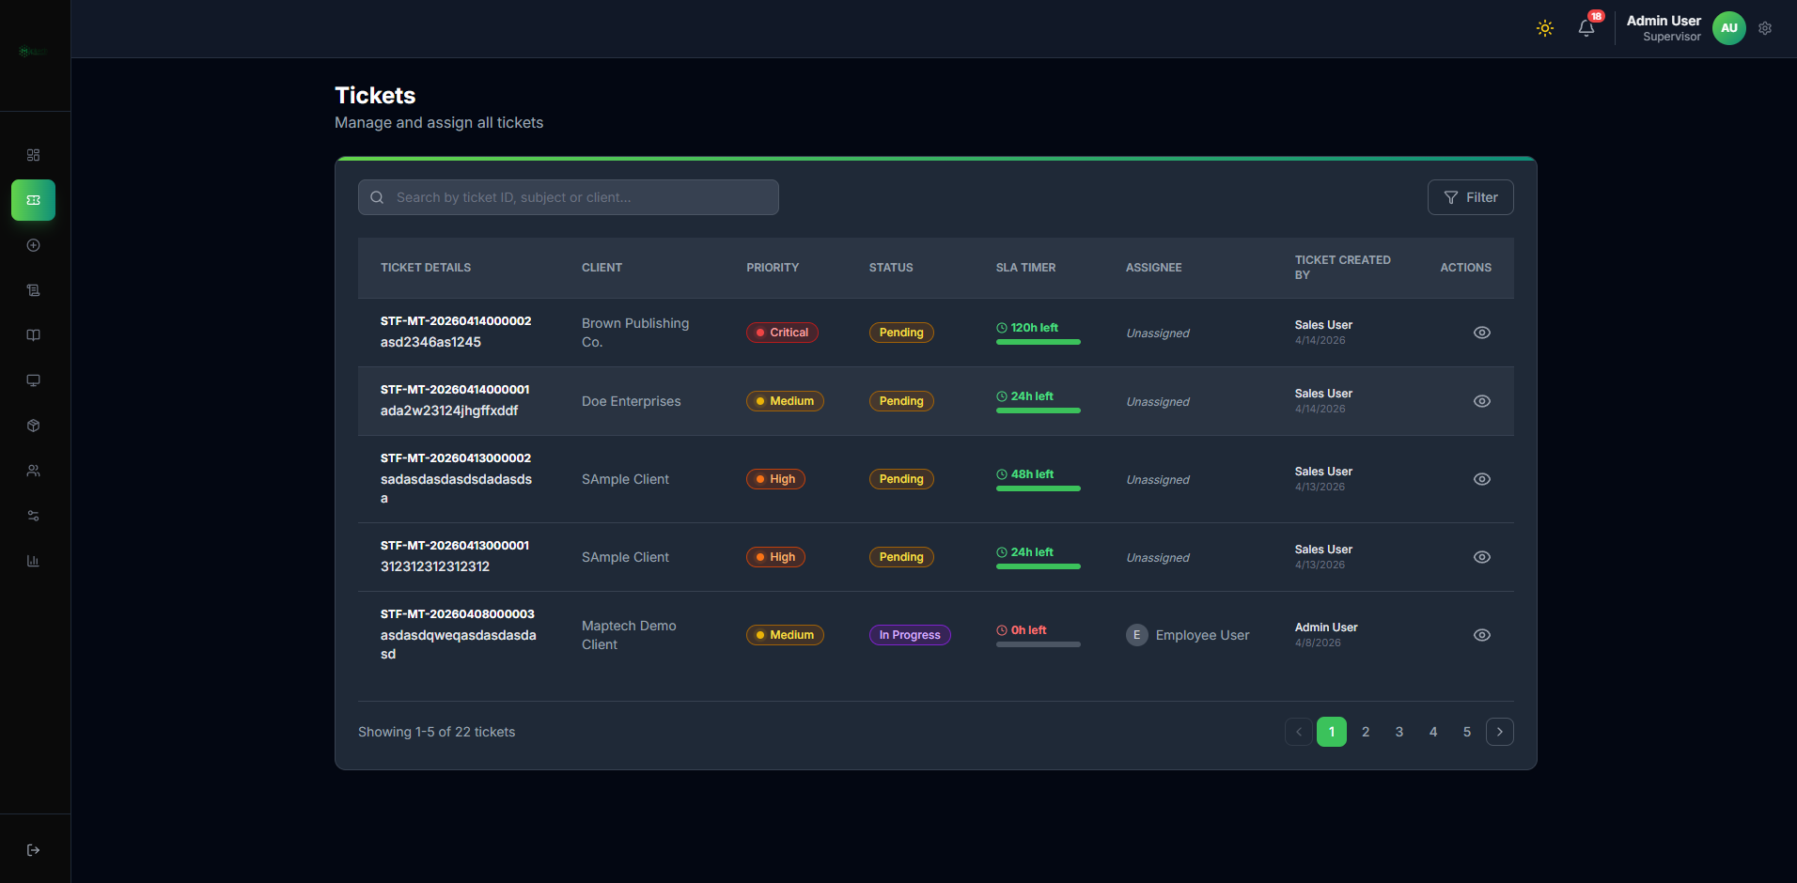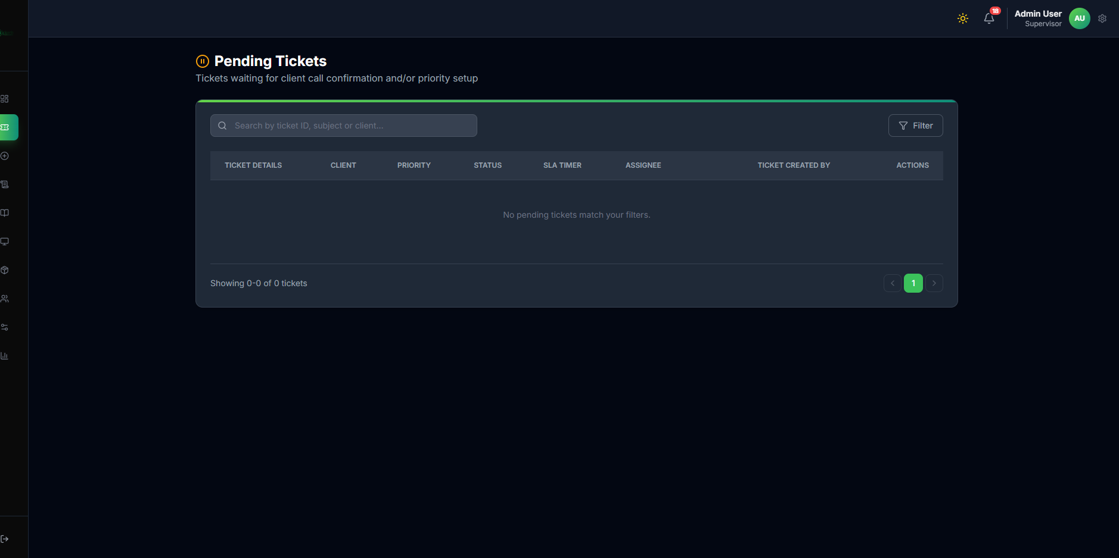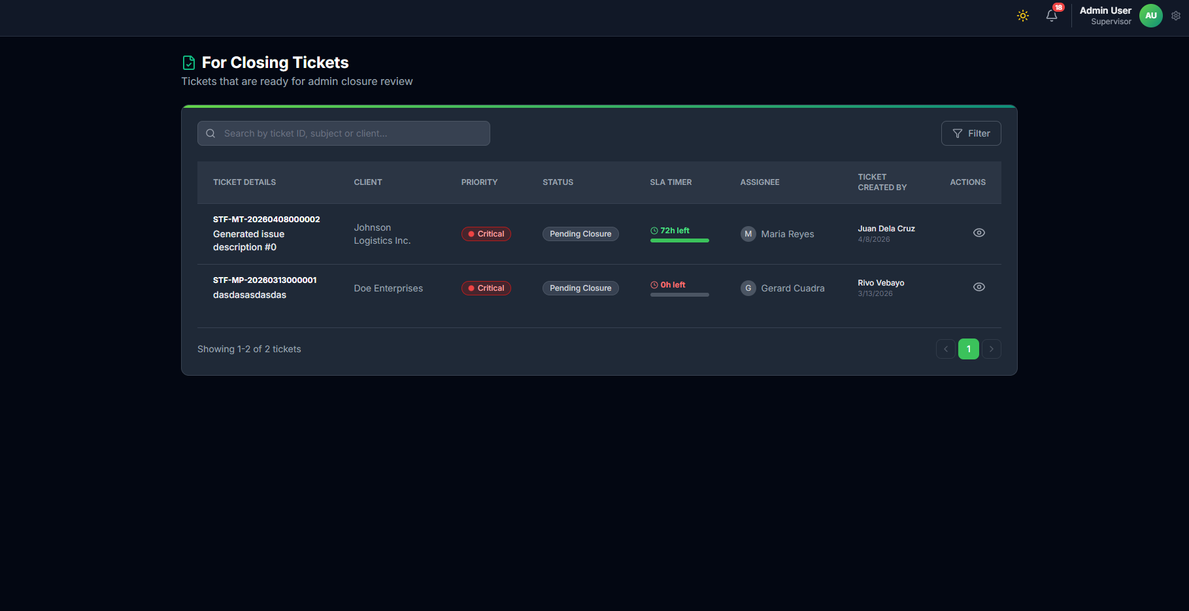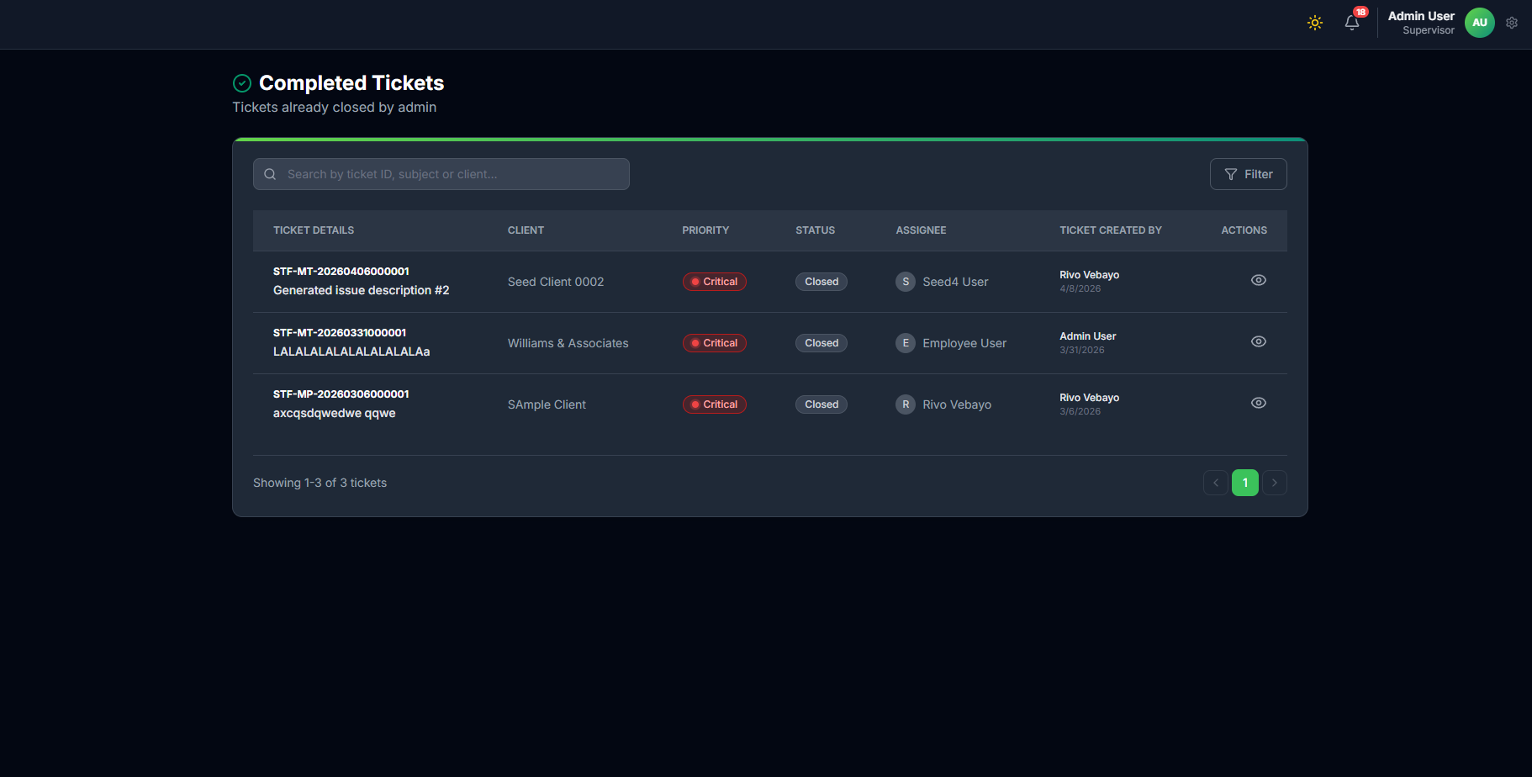
Purpose: - Central ticket lifecycle control.
Key Actions: 1. Search/filter by STF number, client, status, priority. 2. Open ticket details for assignment, review, and closure decisions. 3. Track Open, In Progress, Escalated, Escalated External, For Observation, Pending Closure, Closed, and Unresolved states. 4. Resolve stuck tickets by reassignment, escalation handling, or closure decision.

1.5.1 5.1 Resolution Routing by Ticket State
State Line T1 (Open): Validate ticket quality and assign technician.
State Line T2 (In Progress): Monitor updates, SLA, and intervention needs.
State Line T3 (Escalated): Reassess scope and reassign to correct technical resource.
State Line T3A (Escalated External): Track external vendor/distributor progress and route back when actionable.
State Line T4 (For Observation): Track monitoring outcome and return to active or close when appropriate.
State Line T5 (Pending Closure): Perform final review and feedback before closing.
State Line T6 (Closed): Confirm closure quality and optionally publish to knowledge base.
State Line T7 (Unresolved): Review unresolved reason, decide reopen path, and route back to active handling when needed.

1.6 6. Create Ticket Module (Supervisor Intake)
Purpose: - Encode complete and valid ticket details before dispatch.
Visual Flow: Open Create Ticket -> Select Client Type -> Select Product Type -> Add Service + Problem -> Review -> Submit -> Ticket Open

1.6.1 Screens and Explanation
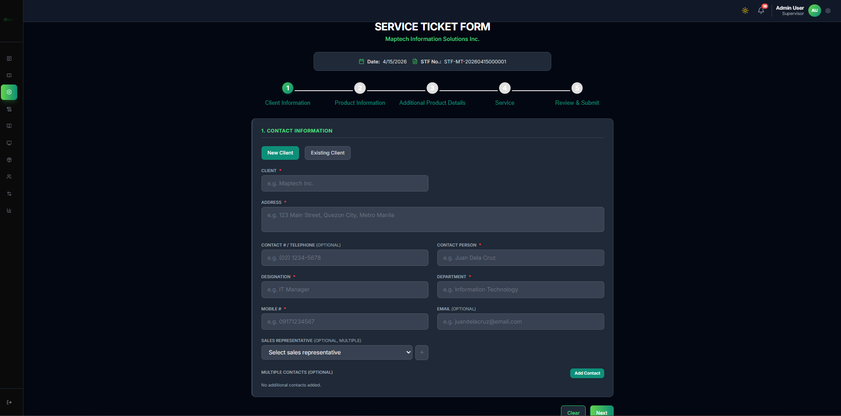 Explanation: Use this when the client already exists and supervisor needs to encode the issue quickly.
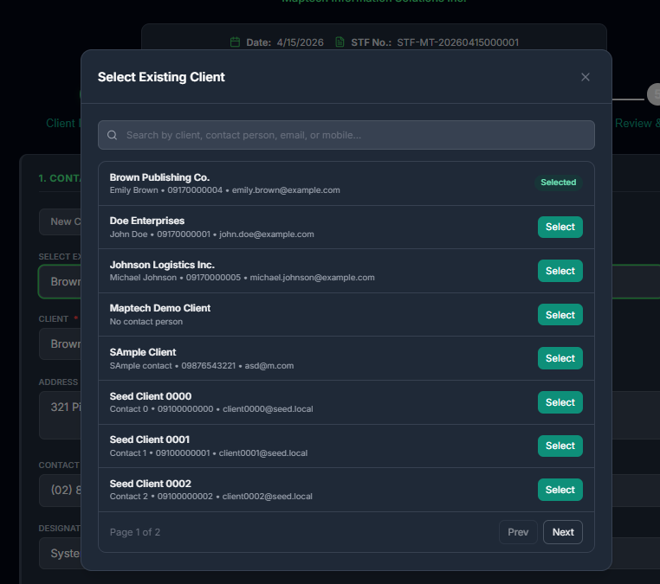 Explanation: Search and select the correct existing client record to avoid duplicate entries.
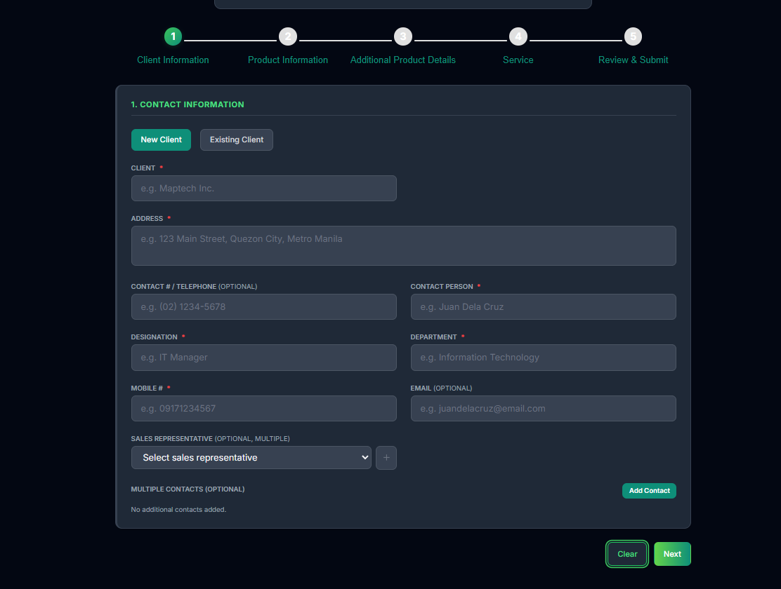 Explanation: Use this when onboarding a first-time client during ticket intake.
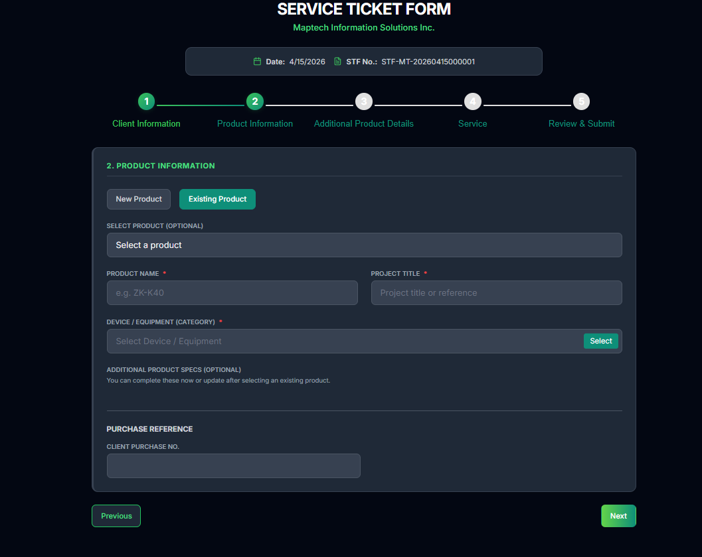 Explanation: Use existing product path when the affected product is already registered.
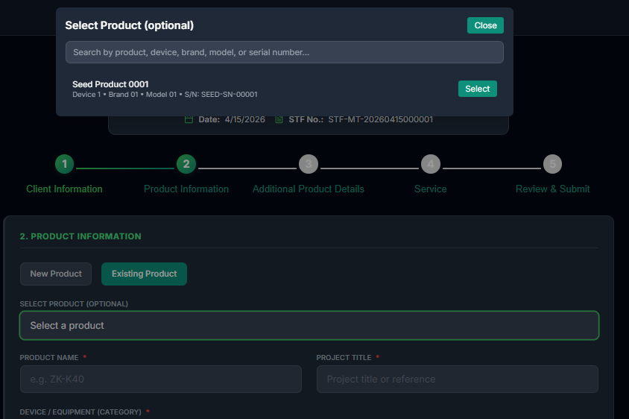 Explanation: Select the exact product/device to improve technical diagnosis accuracy.
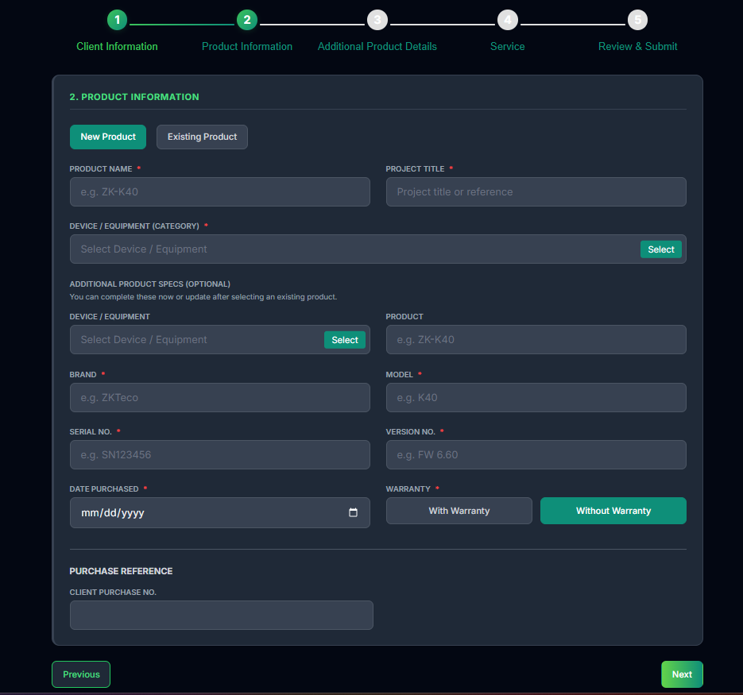 Explanation: Use this when the product is not yet in the catalog and must be encoded.
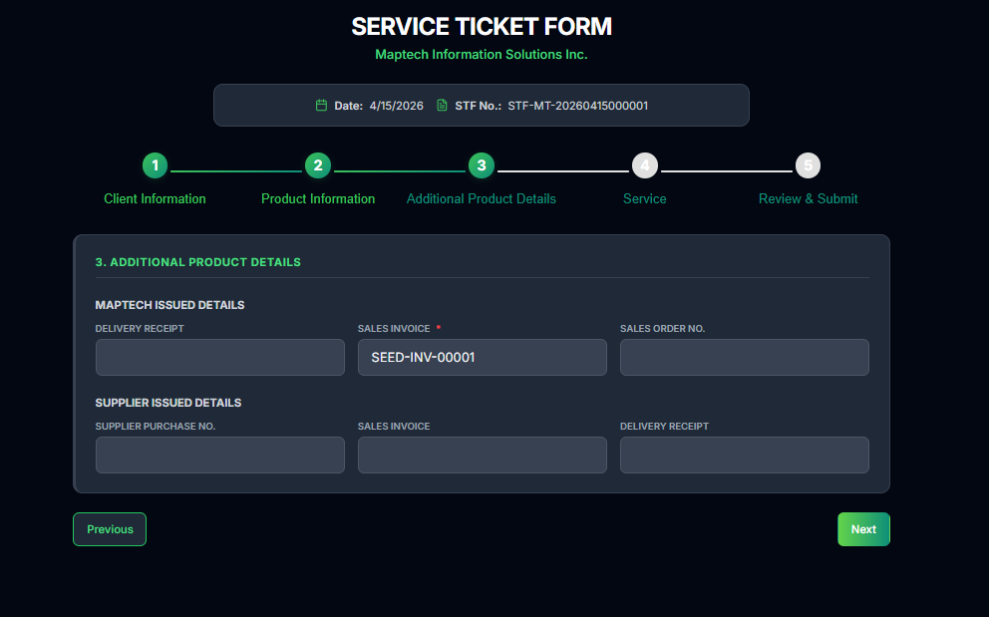 Explanation: Capture serial/reference details and additional technical notes needed for troubleshooting.
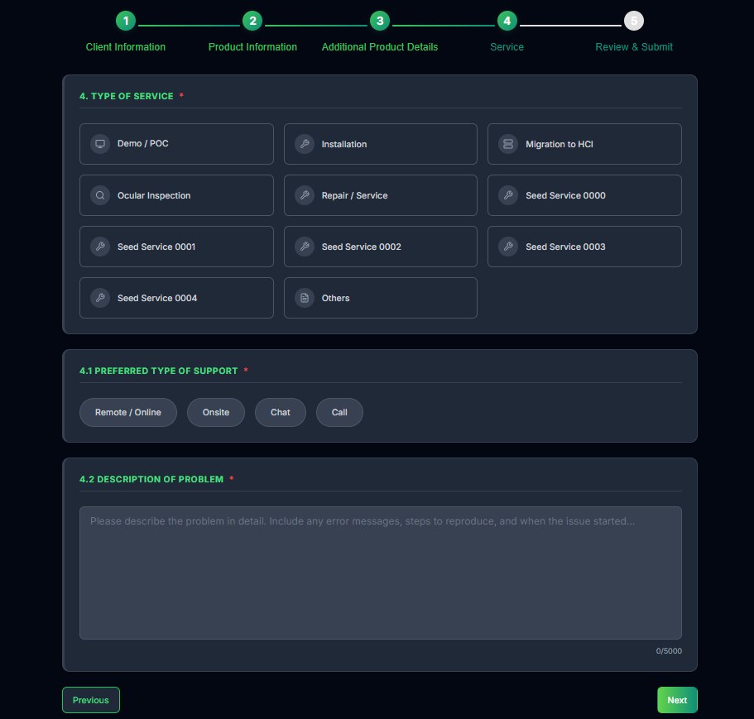 Explanation: Set service type and support preference to align handling and SLA behavior.
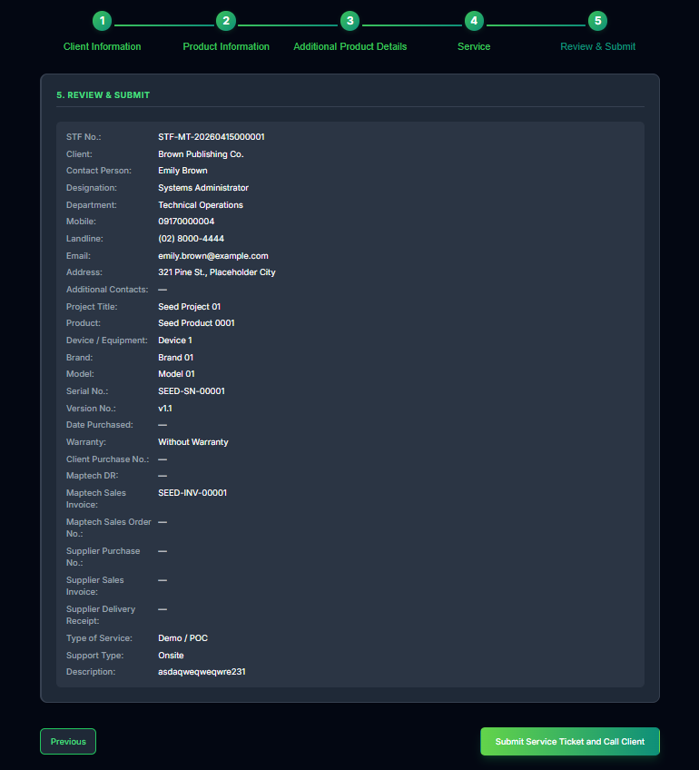 Explanation: Perform final validation before submission and STF generation.
Supervisor Intake Steps: 1. Open Create Ticket and select new or existing client path. 2. Complete client details or select client from lookup modal. 3. Select new or existing product path. 4. Complete product details and additional references. 5. Select type of service and support preference. 6. Encode complete problem statement. 7. Review all details and submit.

1.6.2 6.1 Assignment Readiness Rules (Documented)
Purpose: - Apply the documented assignment gate rules before dispatching to technical staff.
Rules: 1. For sales-created tickets, assignment proceeds after sales call verification, priority setup, and confirmation. 2. For supervisor-created tickets, assignment may proceed immediately after ticket creation when intake data is complete. 3. Supervisor validates ticket completeness and priority before assigning technician.

1.7 7. Assignment and Closure Workflow (Critical)
Purpose: - Control assignment quality, reassignment decisions, and final closure approval.
Visual Flow: Open Ticket Queue -> Open Assign Technical -> Review Technician Workload -> Assign Ticket -> Monitor Progress -> Pending Closure Review -> Close Ticket
Reassignment Branch: Monitor Progress => [Mismatch/Stall/Escalation] Reassign Technician -> Continue Active Resolution

1.7.1 Screens and Explanation
 Explanation: Main ticket queue where supervisor opens verified tickets for assignment action.
 Explanation: Pending queue for tickets requiring immediate assignment or routing decision.
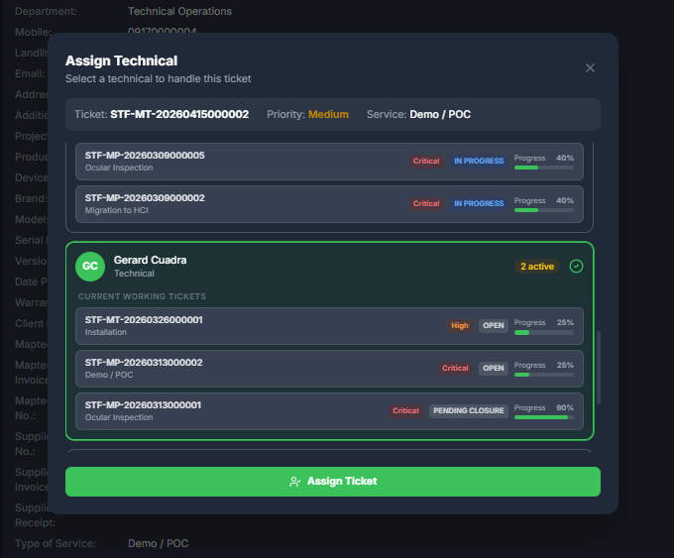 Explanation: Assignment modal showing technician workload, active tickets, and progress before final assignment.
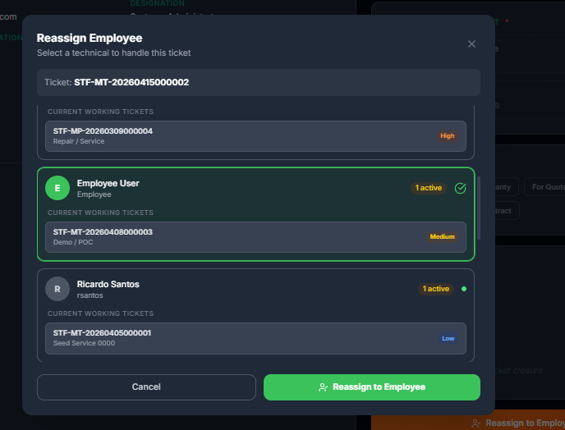 Explanation: Reassignment view for changing assigned technician when workload, skill fit, or escalation requires it.
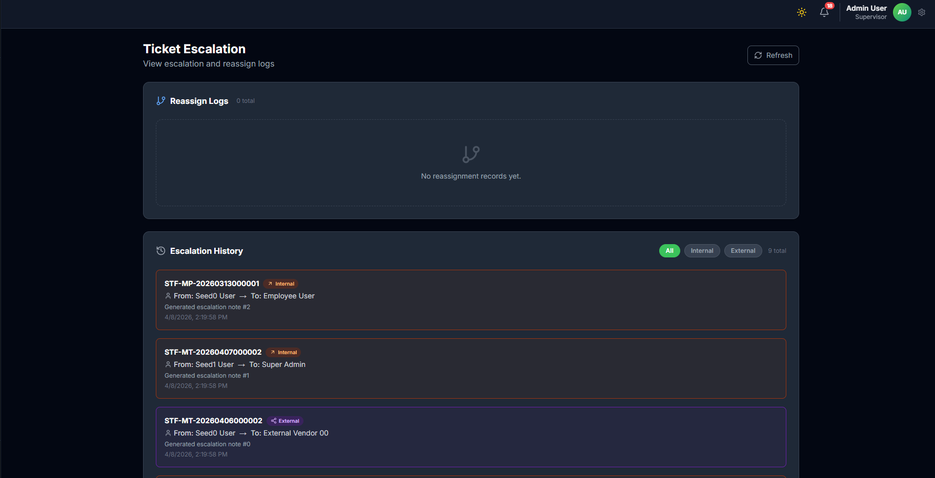 Explanation: Escalation trail used during reassessment and reassignment decisions.
 Explanation: Queue for closure requests awaiting supervisor review.
 Explanation: Final queue used to confirm successful closure and record quality completion.
Assignment-to-Closure Steps: 1. Open verified ticket from All/Pending queue. 2. Recheck ticket details, call verification status, and priority. 3. Open Assign Technical modal. 4. Compare technician active load and current progress indicators. 5. Assign best-fit technician based on availability and capability. 6. Monitor ticket updates, SLA urgency, and work notes. 7. Reassign if assignment fit is poor, progress stalls, or escalation requires specialist handling. 8. Receive closure request with complete proof from technician. 9. Review proof, work notes, and issue-outcome alignment. 10. Submit technical feedback rating. 11. Close ticket and verify appearance in completed queue.
Escalation Decision Flow Lines: - Flow Line E1: If technician escalates internally, supervisor receives escalated ticket. - Flow Line E2: If technician uses pass flow, assignment rotates to selected technician with a new assignment session. - Flow Line E3: Supervisor reassesses scope and reassigns technician when needed. - Flow Line E4: If external support is needed, escalation is tracked as external. - Flow Line E5: Ticket re-enters active workflow until closure criteria are met.

1.7.2 7.1 Detailed Supervisor Resolution Procedure
Resolution Line R1: Open ticket in Pending Closure queue.
Resolution Line R2: Validate technical action notes and remarks for completeness.
Resolution Line R3: Review uploaded proof attachments for quality and relevance.
Resolution Line R4: Check ticket outcome against original issue description.
Resolution Line R5: Submit required technical staff feedback/rating.
Resolution Line R6: Close ticket and confirm status changed to Closed.
Resolution Line R7: Verify ticket appears in completed history.
Resolution Line R8: Publish reusable resolution evidence to Knowledge Hub when applicable.

1.8 8. Escalation Module
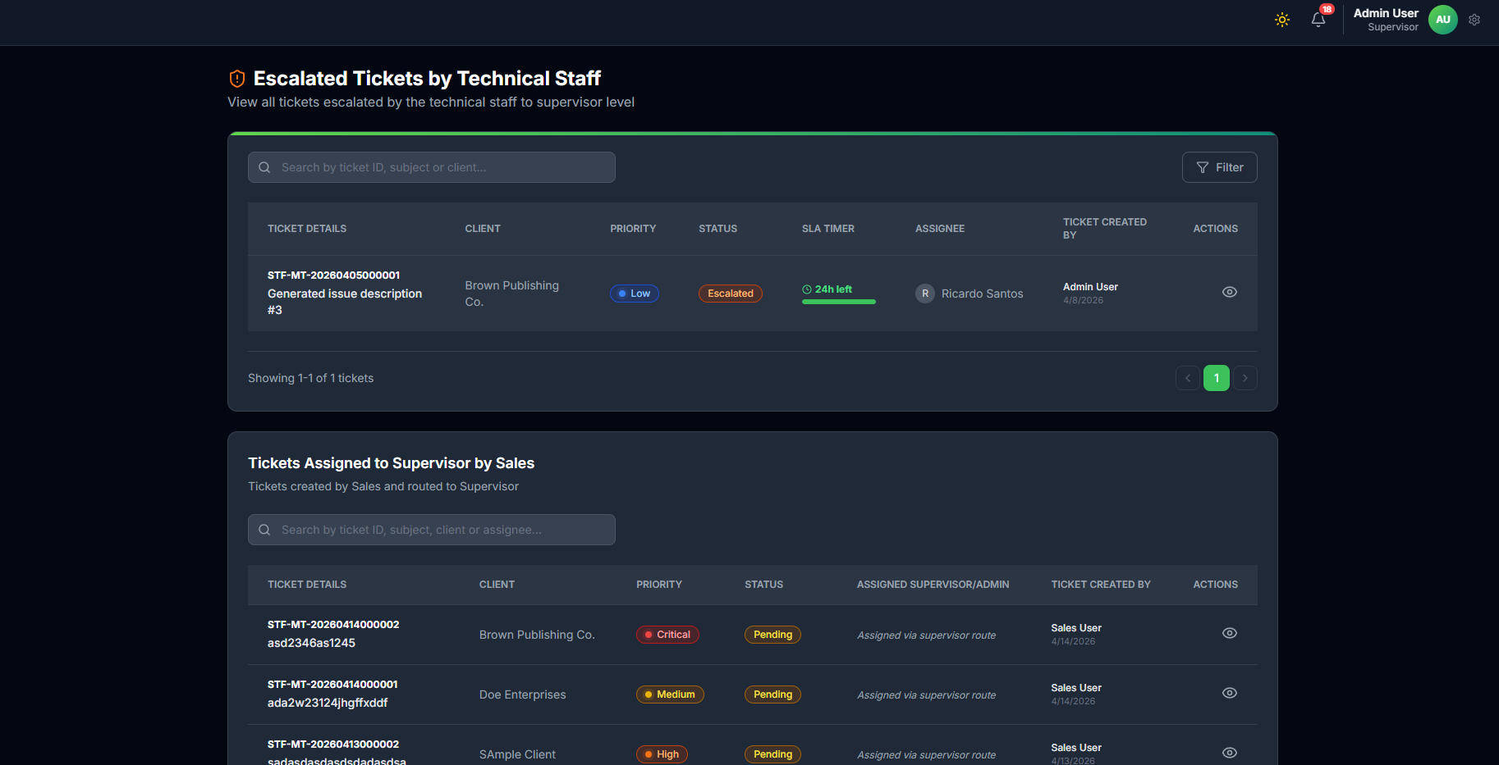
Purpose: - Monitor reassignment logs and escalation history.
Steps: 1. Review reassignment records. 2. Review escalation history (internal/external tags). 3. Take action: reassign, monitor, or route externally.
Escalation-to-Resolution Lines: - Flow Line ER1: Receive escalated ticket in escalation view. - Flow Line ER2: Confirm escalation reason and context. - Flow Line ER3: Handle pass-driven reassignment sessions and validate target technician fit. - Flow Line ER4: Assign best-fit technician or continue external tracking. - Flow Line ER5: Monitor returned ticket until it reaches Pending Closure. - Flow Line ER6: Complete final closure procedure when ticket is resolvable.

1.9 9. Knowledge Hub Module
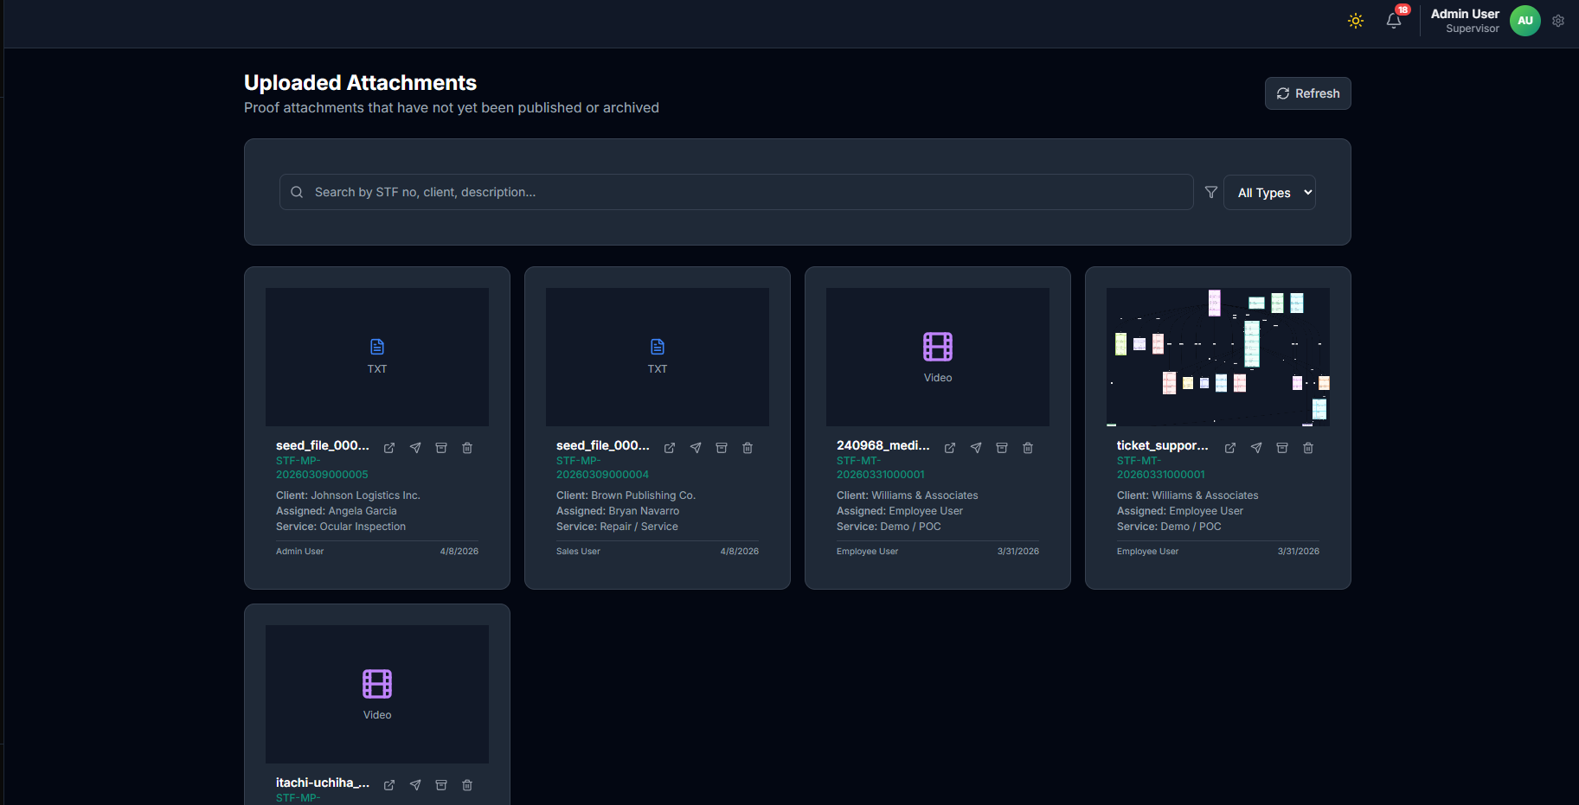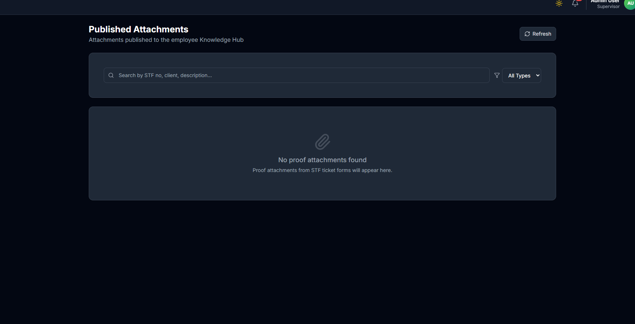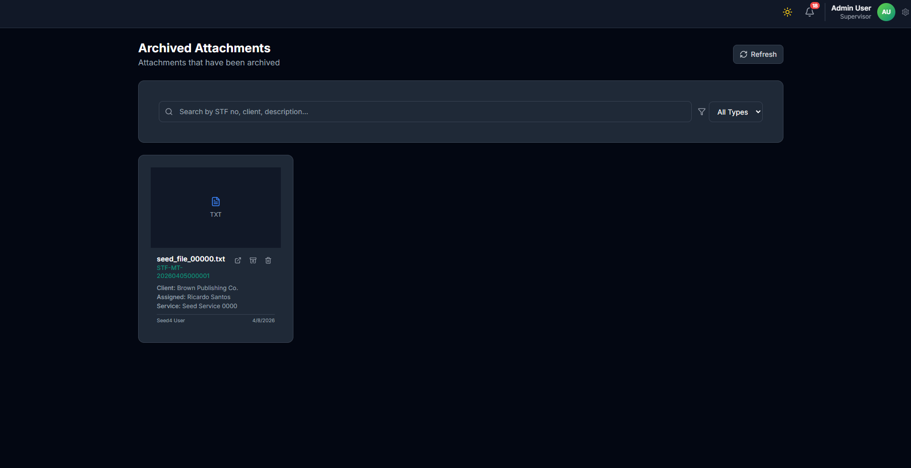
Purpose: - Convert resolved ticket proofs into reusable knowledge.
Publishing Steps: 1. Open uploaded attachments list. 2. Select valid proof file from resolved ticket. 3. Publish with title, summary, and tags. 4. Archive outdated entries when necessary.

1.10 10. Call Logs Module
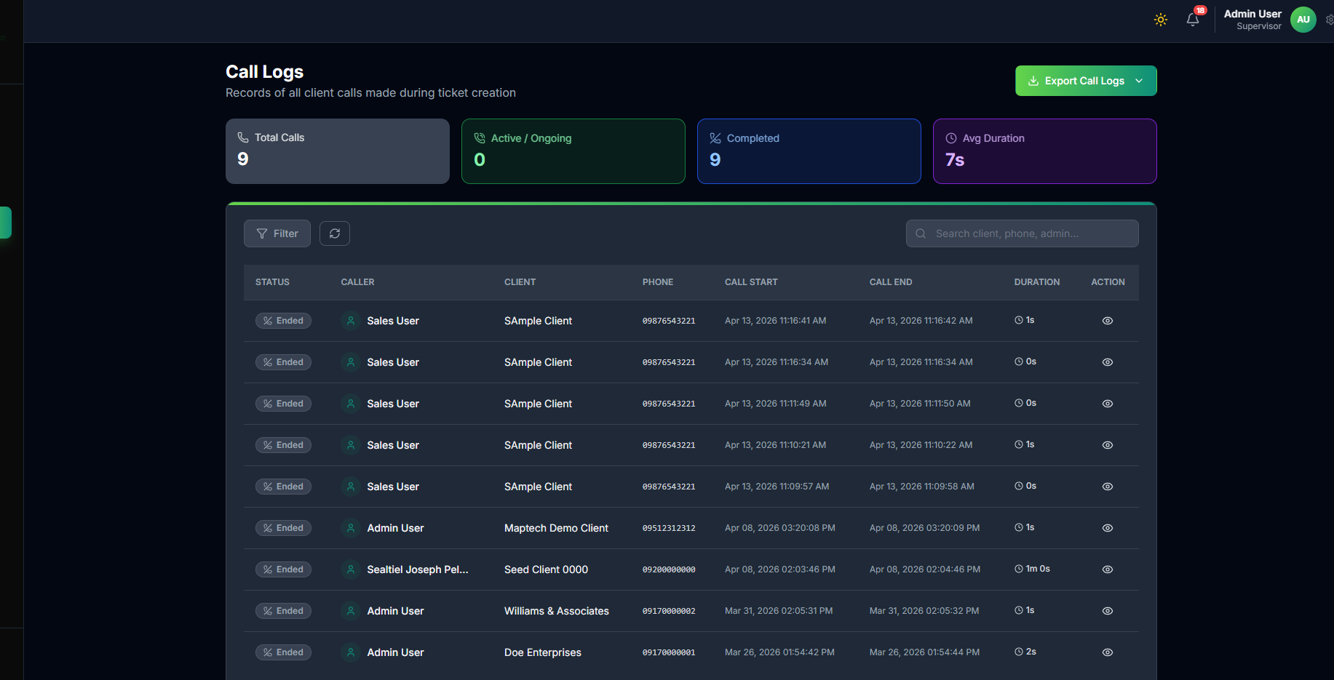
Supervisor Call Logs
Purpose: - Track client call records linked to support workflow.
Steps: 1. Filter or search call records. 2. Review caller, client, call start/end, and duration. 3. Use logs for follow-up validation and auditing.

1.11 11. Audit Logs Module
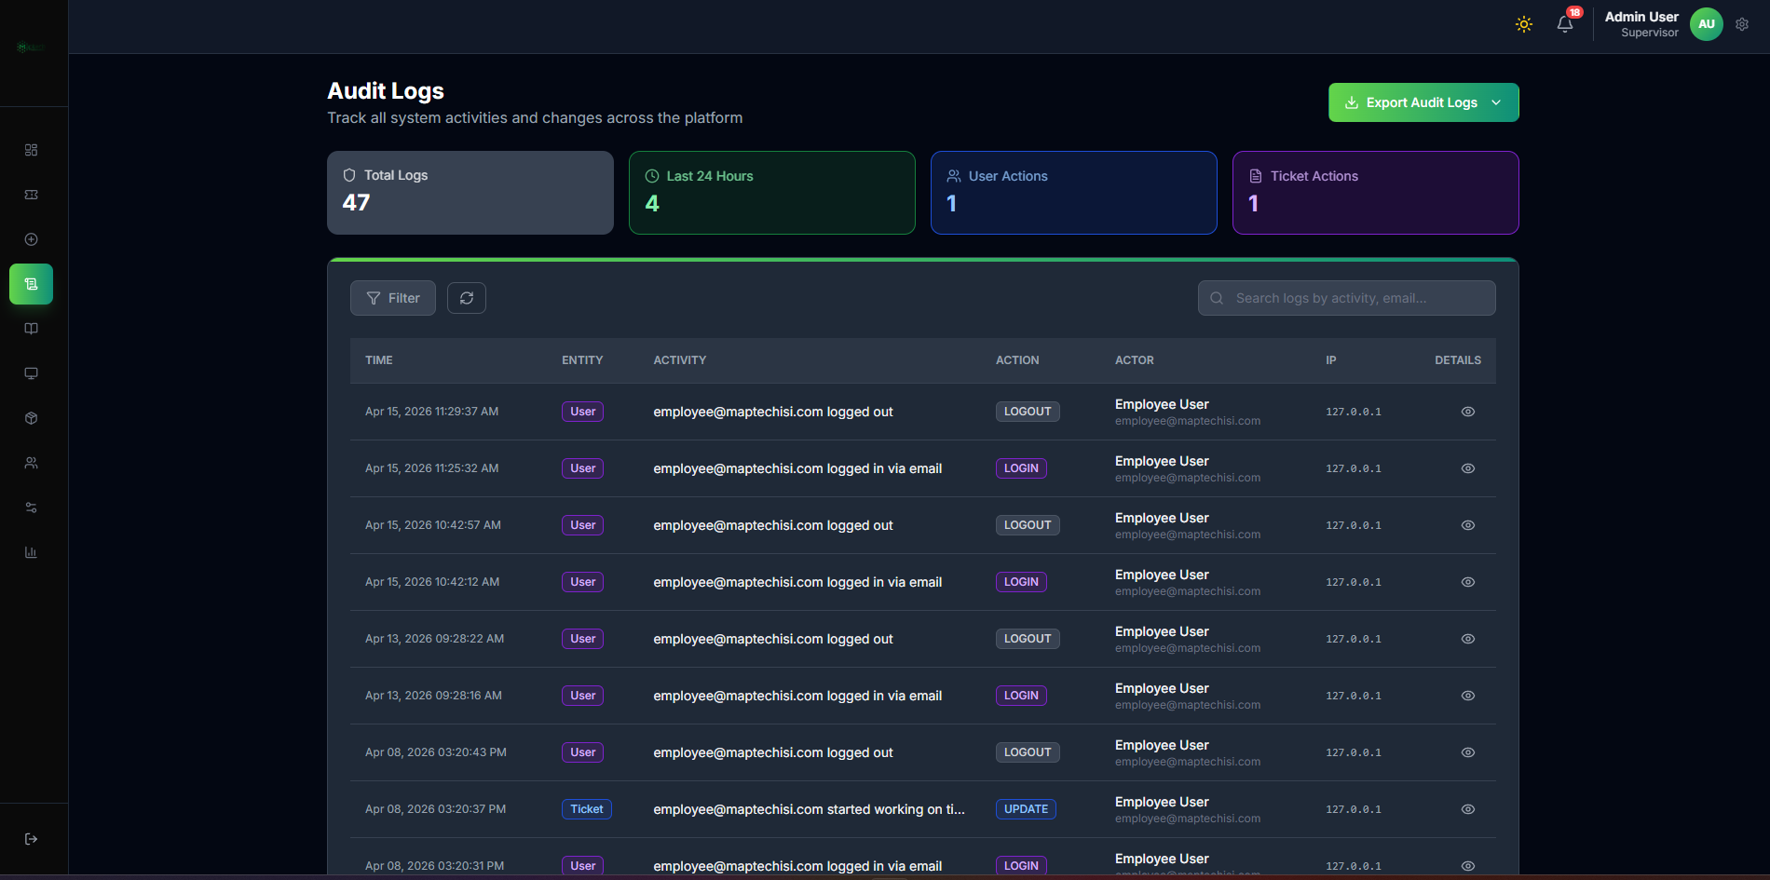
Supervisor Audit Logs
Purpose: - Track system activities within allowed supervisor visibility scope.
Steps: 1. Filter by action/entity/date range. 2. Review actor, timestamp, and details. 3. Export as needed.

1.12 12. Clients Module
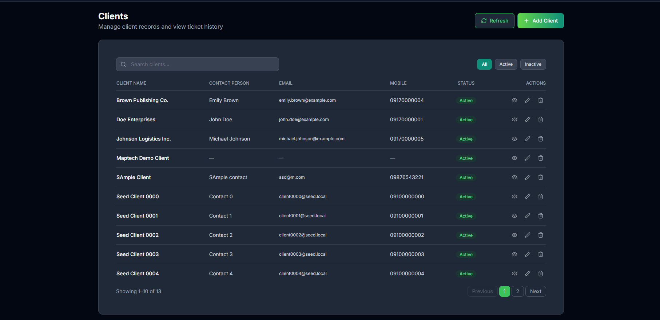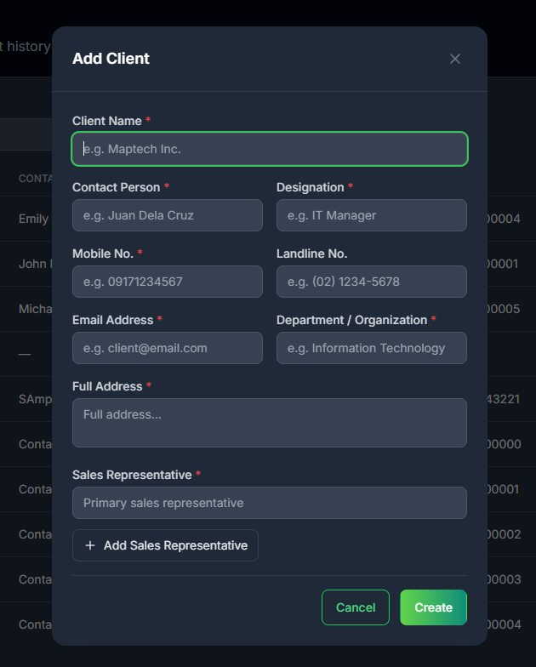
Purpose: - Manage client records used in ticket intake.

1.13 13. Products Module
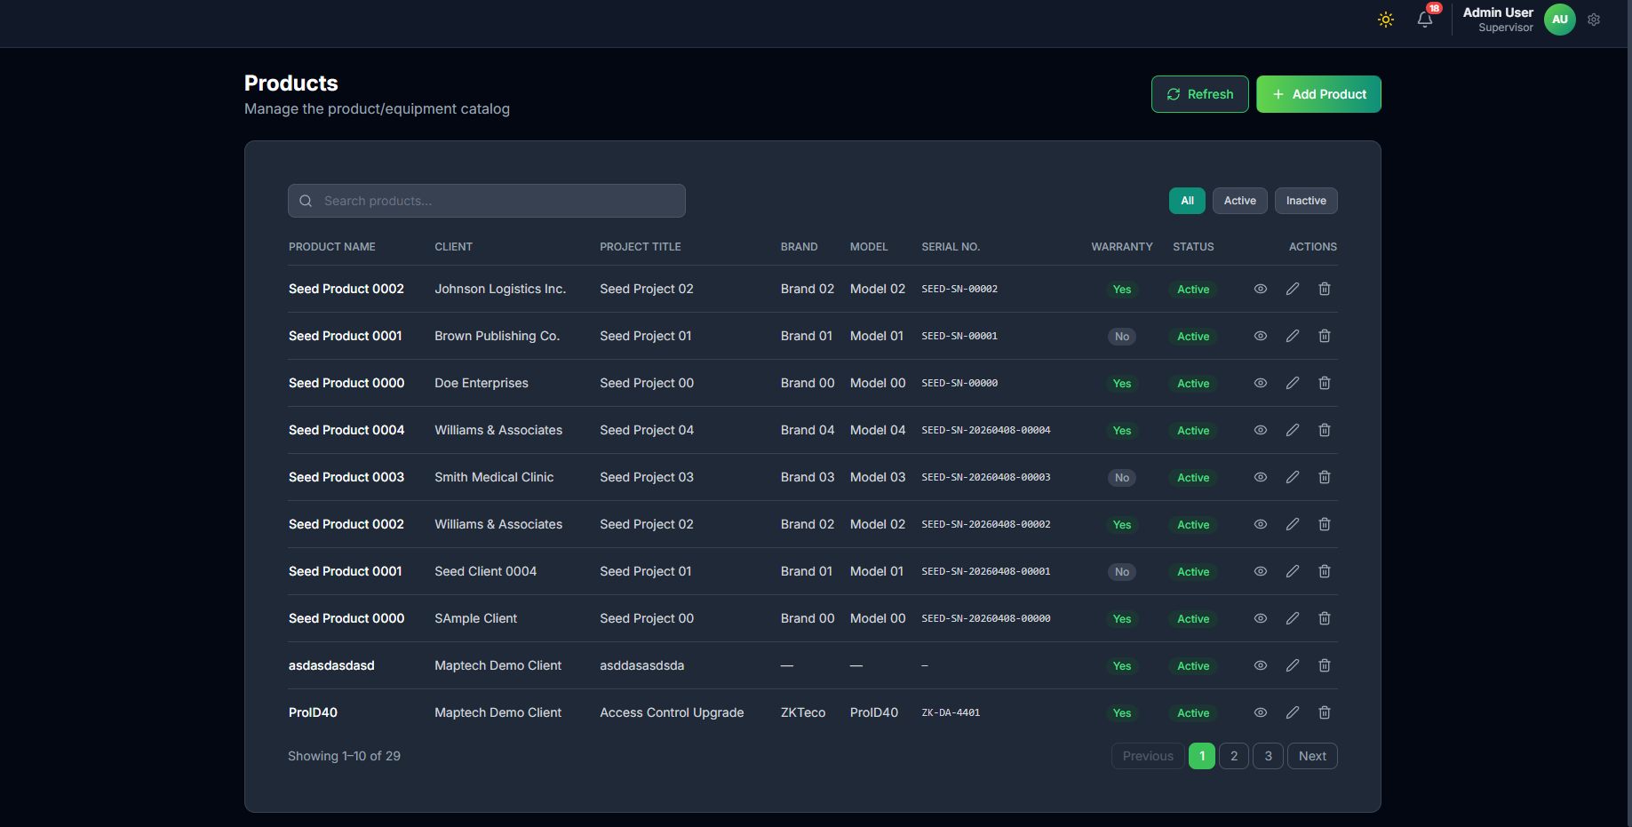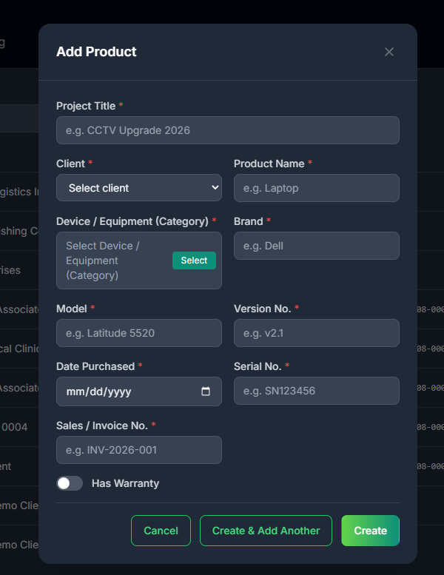
Purpose: - Maintain product catalog for accurate ticket linkage.

1.14 14. Device/Equipment Category Module
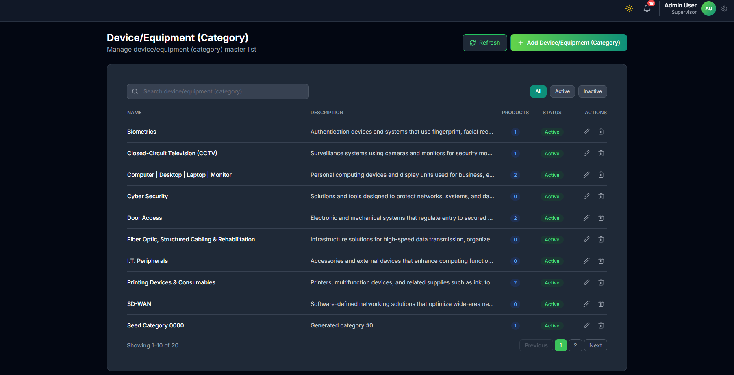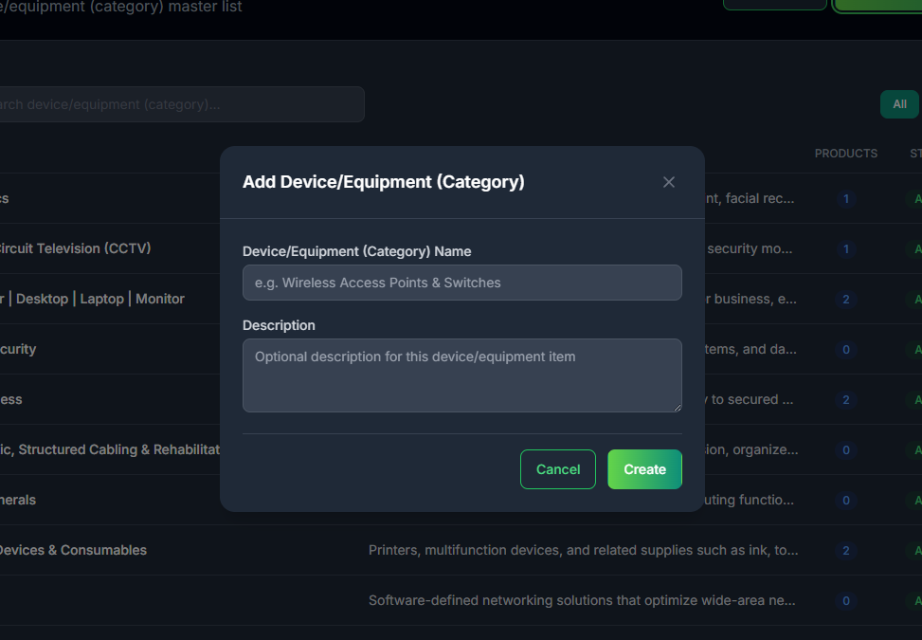
Purpose: - Maintain category taxonomy for devices and products.

1.15 15. Types of Service Module
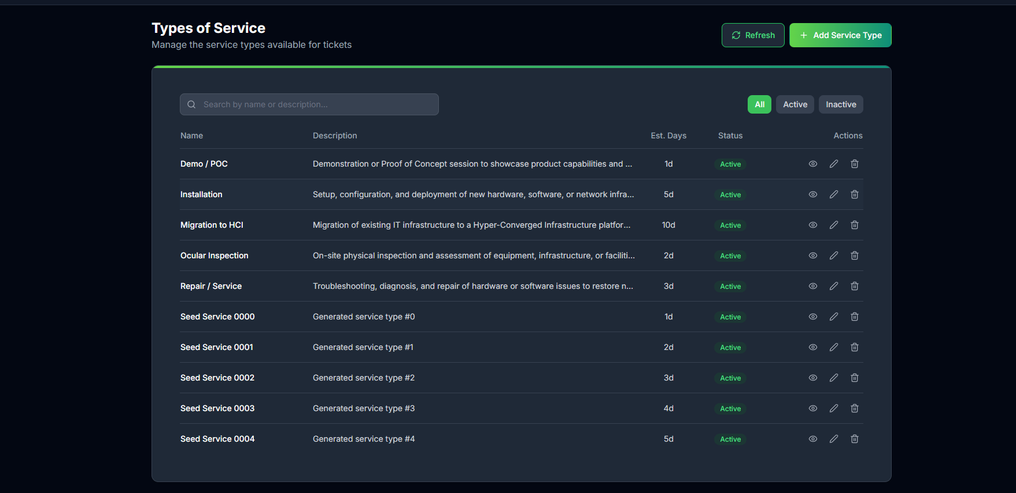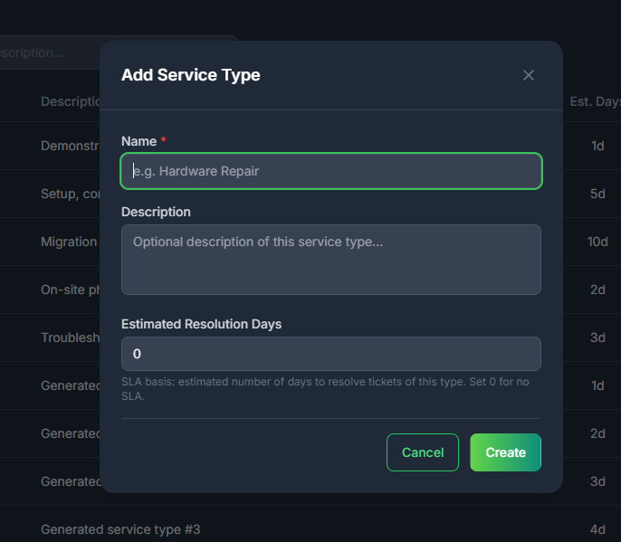
Purpose: - Define service options and estimated resolution days for SLA behavior.

1.16 16. Reports Module
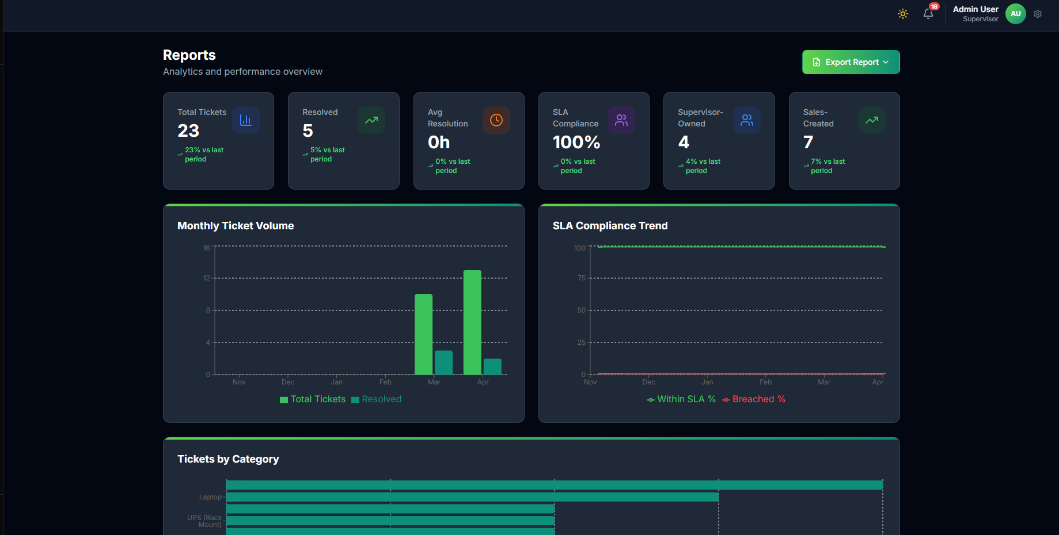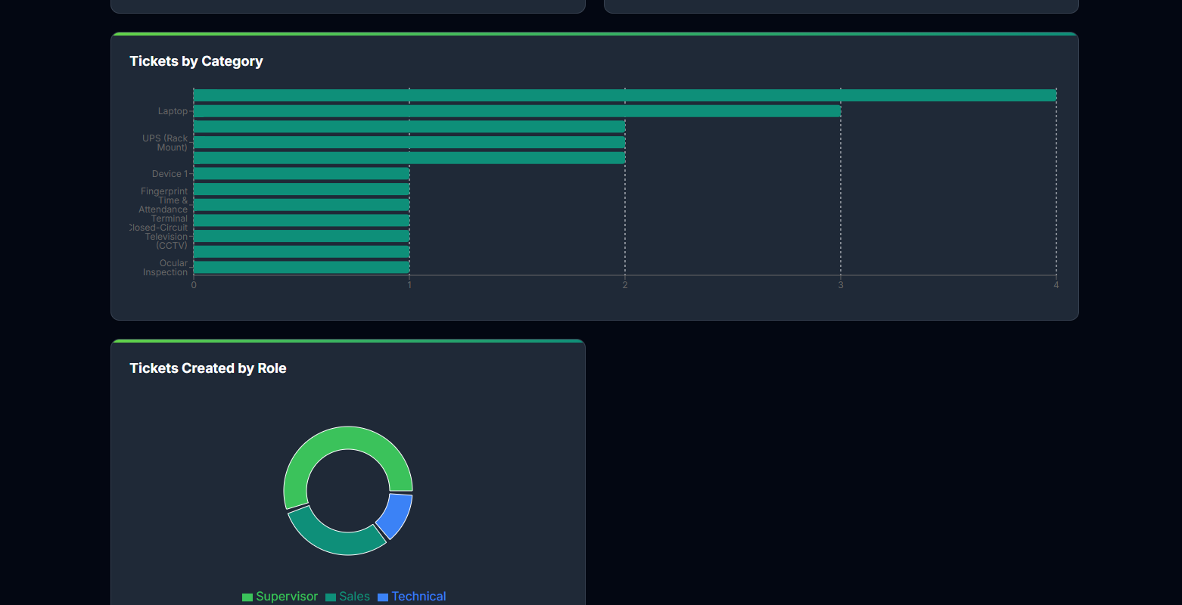
Purpose: - Analyze monthly volume, SLA trends, and ticket distribution.
Resolution KPIs to Review: 1. Resolved versus pending trend. 2. Escalation recovery rate. 3. Closure turnaround time. 4. SLA compliance performance.

1.17 17. Settings Module
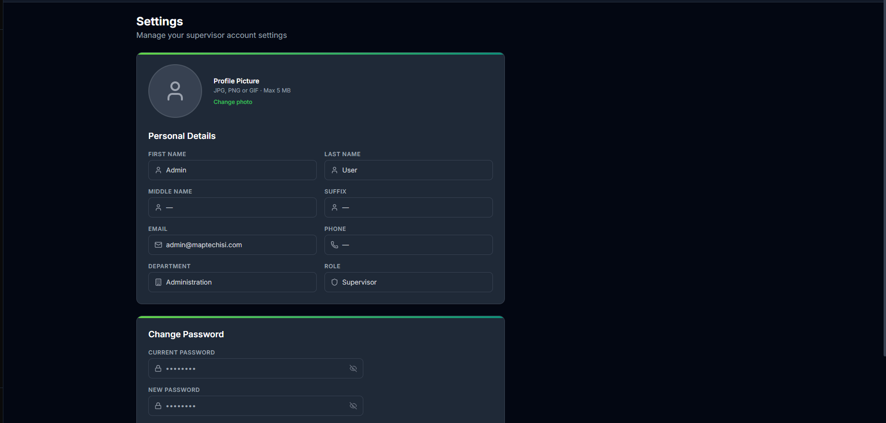
Supervisor Settings
Purpose: - Update profile and password, and check account-specific preferences.

1.18 18. Supervisor Quality Controls
- Do not close tickets without sufficient proof and proper work notes.
- Ensure feedback/rating is submitted before closure finalization.
- Use escalation logs to avoid duplicate routing.
- Publish only reusable and validated knowledge items.

1.19 19. Supervisor End-to-End Summary
Flow Line S1: Intake ticket (create directly or receive confirmed ticket).
Flow Line S2: For sales-created tickets, ensure call verification and priority confirmation are complete.
Flow Line S3: Validate ticket details and assign best-fit technician.
Flow Line S4: Monitor progress and SLA urgency.
Flow Line S5: Handle escalation or observation branches when needed.
Flow Line S6: Review closure request and submit feedback.
Flow Line S7: Close ticket and optionally publish knowledge proof.

1.20 20. Supervisor Resolving Ticket Workflow (Per Module)
Module Line M1 (Tickets): Route each ticket to the correct next action by state.
Module Line M2 (Escalation): Convert escalated tickets back into active resolution path.
Module Line M3 (Closing Tickets): Apply review checklist and finalize closure.
Module Line M4 (Completed Tickets): Validate closure completion and audit consistency.
Module Line M5 (Knowledge Hub): Publish reusable closure evidence for future resolutions.

1.21 21. Lifecycle Reference (Synced with Ticket Lifecycle Manual)
This section is synchronized with Ticket-Lifecycle-Workflow.md for supervisor decision consistency.
Lifecycle Line L1 (Open): Validate ticket quality and assign the right technical resource.
Lifecycle Line L2 (In Progress): Monitor SLA and technical progress; intervene when stalled.
Lifecycle Line L3 (Escalated): Review escalation context and route back to active resolution.
Lifecycle Line L3A (Escalated External): Track external escalation updates and route back when resolution can continue internally.
Lifecycle Line L4 (Pending Closure): Execute closure review gate before final approval.
Lifecycle Line L5 (Closed): Validate completed history and publish reusable proof when appropriate.
Lifecycle Line L6 (Unresolved): Reassess unresolved context and reopen to active workflow when corrective path is available.
Closure Gate CG1: Technical action notes and remarks are complete.
Closure Gate CG2: Proof attachments are valid and relevant.
Closure Gate CG3: Feedback/rating submission is completed prior to close.

